ARC LTER Chlorophyll Analysis Protocol 2021
May 2008 Dan White
Revised: 24 March 2020 Sarah Messenger

SAMPLE COLLECTION AND PREPARATION
- With overhead lights off, filter a known amount of water through GF/F 47mm filter (do not use GF/Cs as was done in 2002). Use a filter tower. Filter with the “small suck” pump (<6 inHg/20 kPa)
- Keep filter shaded while manipulating and place in a dry (empty) 15 mL falcon tube made of polypropylene (not polystyrene, which dissolves in acetone). Immediately place tube in the freezer. Do not take acetone out into the field.
- Store tube and filter in a normal freezer (~ no warmer than -10 deg C) for at least one hour and up to 48 hours (to lyse cells). If sample cannot be fully processed within 48 hours, put filter into a -80 deg C freezer (filters may be stored up to 4 months frozen according to Axler & Owen 1994).

REAGENT PREPARATION
- Make up a working solution of 90% acetone using a stock of 100% acetone plus 10% DI water containing 1mg MgCO₃/L DI water.
- For 0.3N HCl, add 7.4 mL of concentrated hydrochloric acid (HCl) to 200 mL of DI. Mix then raise to 300 mL volume.
- Prior to adding acetone to the samples, fill a cooler with ice and place the acetone dispenser bottle in an ice bucket. This will chill the acetone. DO NOT store the acetone in the refrigerator – if fumes fill up the refrigerator it could explode.

EXTRACTION
Turn on “Wonka Hood” in the dark room. Turn off the overhead lights.
- Using re-pipette, add 10 mL cold 90% acetone to each falcon tube. Avoid direct light. Place the tubes into the cooler with the frozen ice packs.
- Extract the chlorophyll for ~24 hours (20-26 hr range) in absolute dark. (Cover tubes with aluminum foil and place in the cooler with the lid closed). In Wetlab we typically extract on Fridays and run on Saturdays.

READING ON FLUOROMETER
- Run samples in sets of 5-10.
- Take samples out of cold box but leave in dark just long enough to allow samples to warm to room temp. Condensation in the tubes will give a bad reading. Additionally, florescence is temperature dependent.
- First run an acetone blank (90% acetone with MgCO₃). Record on Solid Standard Log.
- Check the solid standards with each run, and log the readings on the Solid Standard Log in the Filter Book. The Solid Standards should read +/- 5% of the reading when the instrument was calibrated (see Solid Standard Log). If the values are outside of +/- 5% see Appendix 1 before proceeding.
- Pour sample from Falcon tube into 10 mL borosilicate 13x100 mm tube. Wipe outside of tube with a kim-wipe.
- Place in fluorometer.
- Replace metal cap.
- Allow the instrument to cycle through the three ranges (High, Medium, and Low), then stabilize before reading.
- Record reading under the “Before Acid” column of the Filter Log.
- If the instrument reads “Over” you will need to dilute your sample. Dilute with X parts sample + Y parts acetone, where X and Y are the volumes used. Record the dilution amounts as X/X+Y (ex. 1/5 dilution for 1 part sample, 4 parts acetone) in the notes section of the Filter Log.
- Directly after reading, acidify the sample in the borosilicate tube by adding 100 µL 0.3N HCl. Use an extra glove to cover the tube and invert to mix. Allow the tube to react while you read the next un-acidified sample.
- Repeat steps 5-11 for the remaining samples in the set.

READING PHAEOPHYTIN
After completion of step 12 (above).
- Return to the first borosilicate tube in your set. Wipe outside of tube with a kim-wipe.
- Return borosilicate tube to fluorometer, replace metal cap.
- Allow the instrument to cycle through the three ranges (High, Medium, and Low), then stabilize before reading.
- Record reading under the “After Acid” column of the Filter Log.
- Pour sample in to waste container.
- Put Borosilicate tube into glass waste container.
- Repeat reading chl α and phaeophytin for a new set of 5-10 samples

TUBE CLEANING (falcon tubes)
- Empty the tube into the acetone waste container.
- Flick-out filter into Tupperware container.
- 1 rinse with DI water
- 1 rinse with acetone
- Invert tube in a drying rack
- Be sure tubes are fully dry before reusing
COMPUTE CHL α AND PHAEOPIGMENT:
Chl a and pheopigment concentrations are calculated using the equations given below. The filter_log_working sheet is set up to do these calculations for you but they are given here for reference.

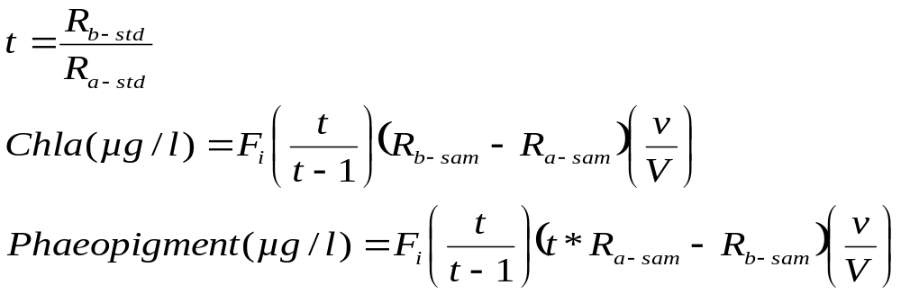

F_{i} = slope of calibration curve for the sensitivity setting used, i = 1x, 10x, …
R_{b-sam} = reading of sample before being acidified
R_{a-sam} = reading of sample after being acidified
R_{b-std} = reading of standard before being acidified
R_{b-std} = reading of standard after being acidified
ν = volume of extract (ml)
V = volume of water filtered (ml)

Note that F and t will be determined at the beginning of the season using pure chlorophyll a standards whose concentrations will be determined using the spectrophotometer.

Note that t is equivalent to r in the EPA protocol

Calculations from Wetzel and Likens, 2000. Limnological Analyses 3rd edition. Note that this reference has a mistake in it, because it does not correct for the volume of extract and volume of water filtered. The above equation properly includes that correction.

References

Axler, R. P., and C. J. Owen. 1994. Measuring Chlorophyll and Phaeophytin: Whom should you believe? Lake and Reserv. Manage. 8(2): 143-151.
EPA, 1995. Method 445.0, In vitro determination of chlorophyll a and pheophytin a in marine and freshwater algae by fluorescence, E.J. Arar and G.B. Collins, revision 1.2.
Wetzel, R. G. and G. E. Likens. 2000. Limnological analyses, 3rd ed. Springer-Verlag, New York.

APPENDIX 1: Re-blanking the fluorometer
Take this step if the solid standards are reading outside +/-5% of their target value.
- Fill a borosilicate tube with 90% acetone used to extract chl a from filters. Thoroughly wipe outside of tube with a Kimwipe, place into the fluorometer and cover with cap.
- On the fluorometer key pad press and hold “ENT”
- On the next screen select “calibration”>”blanking”>”run blank”
- The fluorometer should be on screen #2.11. The blank % should be less than 200%. If it is not, use the down arrow on the key pad to bring the blank % below 200%.
- Allow the fluorometer to stabilize. After the reading is stable press “0”
- Use the “ESC” key to return to the main screen
- Retry the solid standards.
For more help on this issue look at the Turner Designs 10-AU Fluorometer Quick Operating instructions or the user guide. A hard copy is available in Wetlab and both are available on the Turner Designs website: https://www.turnerdesigns.com/10au-field-laboratory-fluorometer

